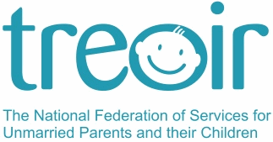

Annual Report 2015
CONTENTS

- ABOUT TREOIR……………………………………………………..………...Page 2
- MESSAGE FROM THE CHAIR…………………………………………….Page 4
- A NOTE FROM THE CEO……………………………………………………Page 6
- NATIONAL SPECIALIST INFORMATION CENTRE………………Page 7
- POLICY DEVELOPMENT / RESEARCH………………………………Page 23
- TEEN PARENTS SUPPORT PROGRAMME………………………....Page 25
- RAISING AWARENESS / PUBLIC RELATIONS……………….…..Page 27
- GOVERNANCE…………………………………………………………….……Page 30
- ACKNOWLEDGEMENTS…………………………………………….…….Page 30

ABOUT TREOIR

Treoir, in partnership with its member agencies, promotes the rights and best interests of unmarried parents and their children through providing specialist information and advocating for their rights.

Treoir is the National Federation of Services for Unmarried Parents and their Children. In 1976 various agencies working with unmarried parents formed a federation to channel efforts and improve the quality of the services provided to unmarried parents and their children. Members include self-help organisations, adoption societies, maternity hospitals, childcare organisations, HSE and accommodation services. In 1995 the Federation was renamed Treoir, which is the Irish word for direction or guidance.

Treoir:

- Operates a free, confidential National Specialist Information and Referral Service on all aspects of unmarried parenthood, providing clear and up-to-date information free of charge to parents who are not married to each other and to those involved with them. These include:

- unmarried expectant parents
- unmarried parents living apart
- unmarried parents cohabiting
- teen parents
- opposite and same sex parents
- grandparents and other relatives
- those working with unmarried parents and their families

- manages the national co-ordination of the Teen Parents Support Programme
- advocates on behalf of unmarried parents and their children

COUNCIL
AUDIT AND FINANCE SUB-COMMITTEE
Ruth Barrington Chair
Dearbhla Ní Riordáin CUH Social Work Dept, Vice-Chair
Christina Hughes Carr’s Child and Family Services, Secretary
Thomas Quigley Bessborough Care Centre, Treasurer

COUNCIL MEMBERS

Breda Collins Limerick Social Services Council
Aisling Dowling-Deignan Regional Adoption Service Tusla
Louise Graham Cura
Mary McCarthy Life Pregnancy Care
Ciara McKenna National Maternity Hospital
Marie Naughton Here-2-Help
Siobhan Roddy Doras Buí
June Tinsley Barnardos
Jennifer O’Grady University of Limerick Maternity Hospital

TREOIR MEMBERS

Aislinn  Barnardos  Bessborough Care Centre  Clarecare  Coombe Women & Infants University Hospital  Cúnamh  CURA | Doras Buí  Familibase Youth Service  Foróige  GLEN -Gay & Lesbian Equality Network  Health Service Executive  Here-2-Help  Home-Start  Life Pregnancy Care Service | Limerick Social Services Council  Mary Immaculate College  Carr’s Child and Family Services  National Maternity Hospital  Rotunda Hospital  Sligo Social Service Council  St. Anne’s Day Nursery  St. Catherine’s Community Services

HONORARY MEMBERS

Dermot Walsh Honorary President
Gemma Rowley Honorary Life Member

STAFF

Margaret Dromey Chief Executive Officer
Margaret Morris National Co-ordinator, TPSP
Brenda Forde Senior Information Officer/ Publications Manager
Veronica Black Information Officer / Training Officer
Beatrice Cronin Marketing Manager / Information Officer
Bella Maher Office Manager
Joanne Hickey Office Assistant

MESSAGE FROM CHAIRWOMAN


In 2015 Treoir welcomed the passage of the Children and Family Relationships Act 2015 as the most important piece of legislation affecting parents and children for a generation. The Act provides for the first time that an unmarried father who is cohabiting with the mother of his child for at least one year – at least three months of which are following the birth of the child – will automatically become the guardian of his child. While welcoming this reform, Treoir considers that the legislation does not go far enough in recognising the rights and responsibilities of all unmarried fathers as guardians of their children. Treoir believes, with the Law Reform Commission, that unmarried fathers should be the automatic guardians of their children – as married fathers are – and that the relationship to the mother should not be the determinant of those rights. Even the limited rights created by the Act are prospective from the date of commencement of the legislation. The Act makes no provision for those fathers who were cohabiting with the mother of their child prior to that date.

Crucially, the Act does not provide for a national register of guardianship, on the model of the register of births, to ensure that information is available to all involved with a child as to who has rights and responsibilities for that child as a guardian. Guardianship of a child by an unmarried father will continue to be established by way of private, unregistered statutory declaration, a most unsatisfactory situation given the importance to children of the rights and responsibilities of their fathers as guardians. Treoir has pointed out that in relation to the land of Ireland there is a central register in the Land Commission of every hectare of the country with the name of the owner. Yet, in relation to our most precious resource – our children – there is no central register of who has rights and responsibilities in relation to their care and welfare. Treoir will continue to highlight the unfairness of the law in relation to the guardianship of children by unmarried fathers and welcomes the commitment by the Minister for Justice, Equality and law Reform, Frances Fitzgerald TD to review the operation of the Act.

Under the UN Convention on the Rights of the Child, every child has the right to know his or her parents and to have the names of both parents on his or her birth certificate. For this reason, Treoir welcomed the enactment of the Civil Registration (Amendment) Act 2014. Provisions of the Act when commenced will place a duty on unmarried parents to register the father’s name on the birth certificate of their child. Only in exceptional cases, where ‘compelling reasons’ are provided, will the father’s name be omitted. Treoir regrets that due to staffing issues in the General Register Office, important provisions of the Act that affect the rights of children have not yet become operational. The UN Committee on the Rights of the Child has drawn attention to one unacceptable provision of the legislation, namely that if parents cannot agree a surname for the child, the birth will be registered but no surname will be assigned to the child until agreement is reached. Treoir calls on the Government to respect the right of every child to have a surname from birth.

The year 2015 was a momentous year for Treoir as we faced the retirement of our much esteemed and long serving Chief Executive, Margaret Dromey. Margaret was synonymous with Treoir for nearly 40 years. She began her career in Treoir in the late 1970s when the stigma of unmarried parenthood was real and the children of unmarried parents experienced serious discrimination. She faced retirement knowing that her leadership of Treoir helped improve the status of unmarried families in society in a way, which those who set up Treoir in the mid 1970s could only dream. Margaret contributed to the major landmarks in the gradual removal of inequalities against unmarried parents and their children, including the Status of Children Act 1987, the Children Act 1997, the Civil Registration Act 2014, the Children and Family Relationships Act 2015 and the Adoption (Information & Tracing) Bill 2014. Margaret was also a key figure in securing a commitment to a national longitudinal study of children. This study, known as Growing Up in Ireland, is following the progress of almost 20,000 children across Ireland to collect information to help improve our understanding of all aspects of children and their development. Margaret’s passion, empathy, sense of fairness, respect for the viewpoints of others, optimism and hard work marked her out as an outstanding chief executive of Treoir. On my own behalf and that of the Council of Treoir I would like to thank her for her contribution to improving the lives of unmarried parents and children in Ireland and for her commitment to the vision and work of Treoir. We wish her well in her retirement.

May I also thank the staff of Treoir for their hard work on behalf of unmarried parents and their children during a most challenging year and express my gratitude to the members of Council for their support and engagement throughout the year.

Ruth Barrington, Chairwoman, May 2016


A NOTE FROM THE CEO

I would like to thank the council, Treoir team and the outgoing CEO Margaret Dromey for the very warm welcome I have received. I’m delighted to have been given the opportunity to lead Treoir and serve the needs of unmarried parents and their children.

When looking at the strategic priorities and aims of Treoir, 2015 was a highly productive and successful year. The breadth and scale of work undertaken by a small team is truly impressive. Close to 9,000 queries were dealt with by the team, 12,000 Information Packs for Unmarried Parents were distributed, 65,000 visitors were recorded on the website and 25 information workshops were provided to over 500 people throughout Ireland. Treoir also continued to provide coordination for the eleven Teen Parents Support Programme projects, through regular meetings, training, advocacy and support.

In addition to core service activities, the organisation worked tirelessly in bringing forth amendments to the Children and Family Relationships Act 2015 and the passing of this Act has undoubtedly changed the landscape for unmarried fathers in a positive and fundamental way. I look forward to taking on the task of furthering the cause of ensuring automatic rights to guardianship for unmarried fathers in particular.

Another key aspect of the work of Treoir is to raise awareness of the issues affecting unmarried parents and the availability of support. Amongst the many press releases, Treoir was featured widely in the media, including various television appearances and radio interviews. It will be important to build on this work and continue to place the cause of Treoir on the public and political agenda.

The current strategic plan of Treoir is due to finish at the end of 2016 and the process of looking forward to the next strategic period is already underway. We hope to begin a process of consultation with all of our stakeholders shortly, including engaging with unmarried parents and the membership. With an excellent team and a solid foundation of support from the members and donors I believe that Treoir is in an excellent position to further its vision of equality and respect in the constitution, laws and services of Ireland for unmarried families.

Greg Straton, CEO, May 2016

NATIONAL SPECIALIST INFORMATION SERVICE

Treoir will maintain and develop the National Specialist Information Service for unmarried parents, same or opposite sex, expectant parents, parents living together or apart, their extended families and those working with them.

A. CALLS TO THE NATIONAL INFORMATION CENTRE

Treoir National Specialist Information Service dealt with approximately 8,964 queries in 2015, a 17% rise compared to 2014.

1. Contact Person
In 2015, 70% of the queries were made directly by individual clients. Professional and Family Members were the second and third largest categories respectively requesting Treoir’s Specialist Information Services. The least number of calls came from the Friend category. In comparison to 2014 there was a 3% decrease in queries from Individual Clients balanced by a 2% increase in queries from Professionals and a 1% increase on queries from Family Members (Chart 1).
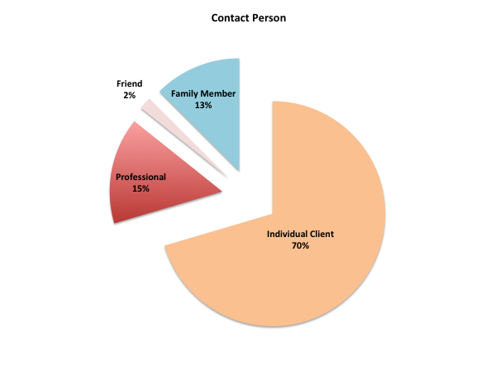
Chart 1

1.1 Individual Client
In 2015, the largest group of individual clients contacting Treoir was Unmarried Mothers (47%) followed closely by Unmarried Fathers (39%). The most significant change, in comparison to the previous year, is that queries from unmarried fathers increased by 5%. Pregnant and expectant parents remained the third largest group (Crisis pregnancy 2%, Pregnant 3% and Expectant Parent 1%) followed by unmarried parents who have subsequently married (5%).
Family members of an individual client (4%) and unmarried parents who were formerly married (3%) were the additional significant categories (Chart 2).
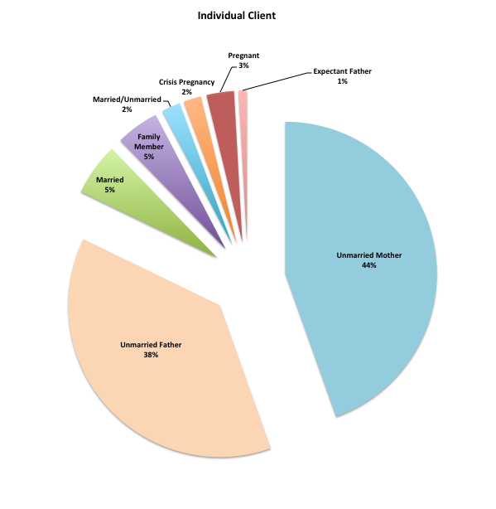
Chart 2

"You guys are always fabulous and its great to have you there.” (Caller, July 2015)

1.2. Professionals
The second largest category contacting Treoir’s Specialist Information Service were professionals working with organisations offering family supports. The majority of queries received came from Citizens Information Centres (45%) followed by Family Resource Centres (18%) and Social Workers (14%). These figures indicate a 21% increase from queries received from Citizens Information Centres in 2014.
Hospitals and Community Services were next with 7% followed by Crisis Pregnancy Services (4%). A fewer number of queries were received from Law Centres (2%), Education Workers (2%), Child and Family Agency (1%) and Doctors (1%) (Chart 3).
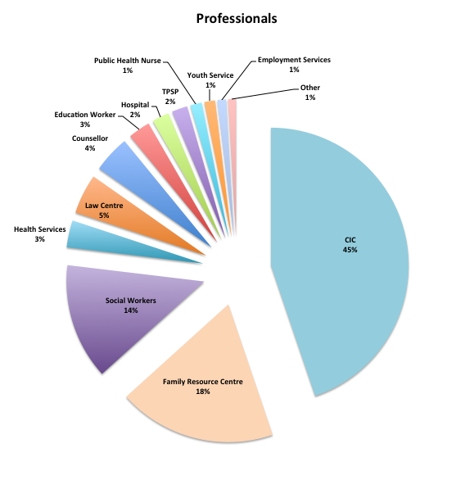
Chart 3

1.3. Family Members
Family Members were the third largest category requesting Treoir Information Services. The majority of family members were maternal grandparents (37%) followed by paternal grandparents (25%). Their queries were mainly related to access to their grandchildren and/or the rights of their adult child. The most significant change from 2014 was a 4% decrease in queries from Grandparents balanced by a 5% increase in queries from family members acting in loco parentis of a child/children that made 6% of the total queries.
10% of the family members contacting Treoir were Adult Children and 10% were Aunts/Uncles while queries from other Siblings amounted to 7%; Wife/Husband of a Single Parent (4%) and Partner of a Single Parent (2%). (Chart 4).

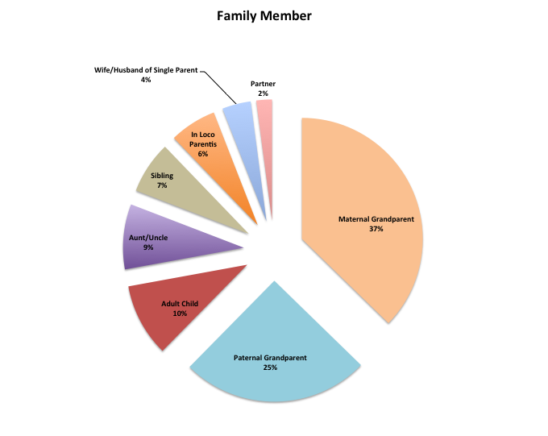
Chart 4

"I have been on to you loads. Only for you we would be jumping off buildings!!” (Grandparent from Kildare, June 2015)

2. Type of Queries
The majority of queries dealt with over the course of the year were of a legal nature (63%) followed by social welfare issues (14%) (Chart 5). There was a slight decrease in queries related to legal issues (5%) and social welfare issues (1%) compared to 2014. Nevertheless there was a 3% increase in queries related to crisis pregnancy queries and a significant 9% increase in queries of other nature.

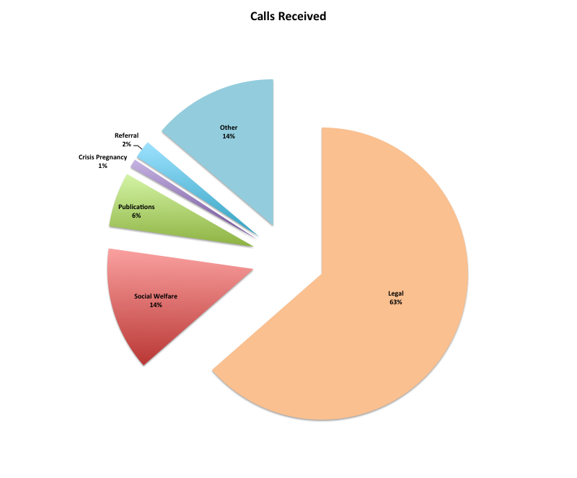
Chart 5

2.1. Legal Queries
The most frequent legal issues dealt with were related to Guardianship (30%), Access (20%), Maintenance (14%), Birth Registration (9%) and Custody (9%). A fewer number of queries were associated to Paternity (4%), Passport (4%), Cohabitation (2%), Abduction (1%), Deed Poll (1%), Adoption (1%), Common Usage (1%) and Civil Registration (Amendment) Act 2014 (1%) issues (Chart 6).

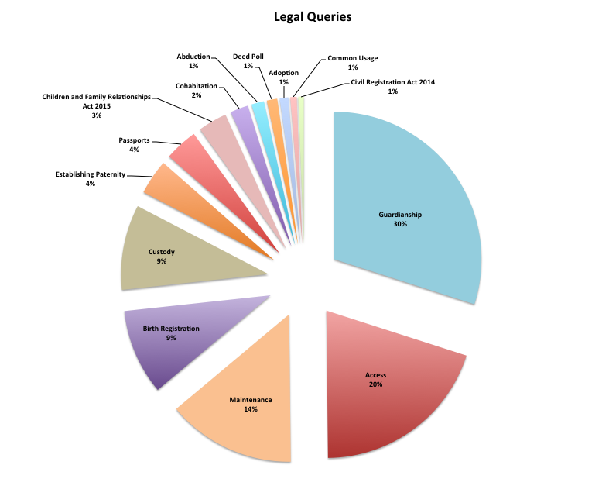
Chart 6

Compared to the previous year, the main significant change is the introduction of two new categories: queries related to the Children and Family Relationships Act 2015 (3%), which was enacted in April 2015, and queries related to the Civil Registration (Amendment) Act 2014 (1%), which was enacted in December 2014 (Chart 7).

In addition, there was a 1% increase of queries related to guardianship. These figures reflect the general demand for information regarding these two pieces of legislation particularly around guardianship.

Significantly, there was a drop in the number of queries related to adoption and domestic violence and an increase in queries related to establishing paternity and changing the child’s name by common usage and/or by deed poll (Chart 8).

Queries Topics 1
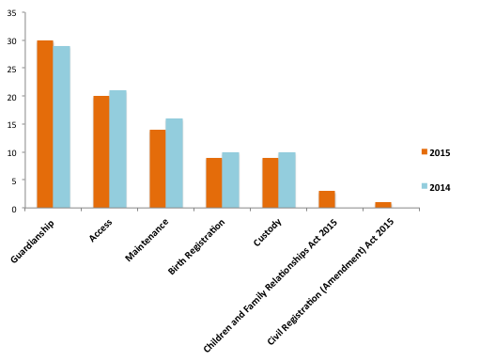
Chart 7

Queries Topics 2
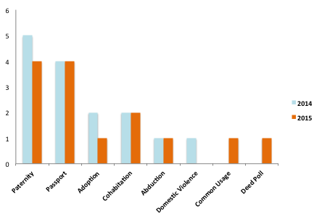
Chart 8

2.2. Social Welfare Queries
The main Social Welfare queries dealt with by the Treoir Specialist Information Service were related to the One Parent Family Payment (46%) followed by Rent Supplement (11%), and Family Income Supplement (11%) (Chart 9).
In comparison to the previous year there has been a decrease in queries related to One-Parent Family Payment, Rent Supplement, Welfare to Work and Welfare to Education. Nevertheless, in 2015 there has been a further 3% increase in queries related to the alternative payments for those transitioning out of the One-Parent Family Payment: Jobseeker Transitional Payment (6%) and Jobseekers Allowance (6%).
The figures reflect the change of government policy regarding the transition of single parents from One-Parent Family Payment to the workforce and the concerns of those families affected. In addition, there has been an increase in queries related to Family Income Supplement (9%), Guardian’s Payment (2%) and Habitual Residence (2%).
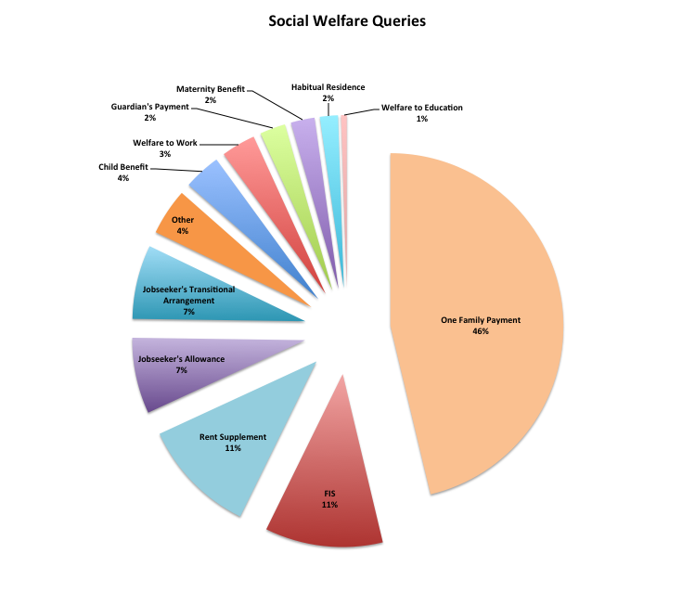
Chart 9
2.3. Other Queries
The additional key topics dealt with by the Specialist Information team were Parenting (65%), and Mediation (16%) (Chart 10). Queries related to Parenting increased by 15% from the previous year while queries related to Mediation increased by 2%. This shows the role that the Treoir Specialist Information Team continues to play in promoting non-court based family dispute resolution amongst unmarried families. On the other hand, there has been a decrease in queries related to Counselling (3%), Income Tax (2%) and Second Line Support (1%).

Importantly, queries relating to Housing accounted for 5% of the queries despite it not being a significant category the previous year. It is likely that this figure reflects the ongoing housing crisis caused by rental rates increases, insufficient rent supplement rates and the lack of available social housing. In addition, there has been an increase in queries related to Child Care (3%). Child care continues to be a main area of concern for single parents who are trying to earn enough to survive following significant changes in Social Welfare payments.

In comparison to 2014, there has been an increase in Single Tax Credit queries (3%). The replacement of the One Parent Family Tax Credit - which was available to both lone parents who are sharing the care of their child(ren) - by the Single Person Child Carer Tax Credit, which is currently available to the main carer only, continues to be a concern amongst single parents. When the main carer is not working she/he may assign the Single Person Child Carer Tax Credit to the other parent, provided that parent has the child in their care for at least 100 days per year. In practice, Treoir is receiving many queries from frustrated parents who work and cannot avail of this financial support because the other parent, who does not work, refuses to relinquish it.

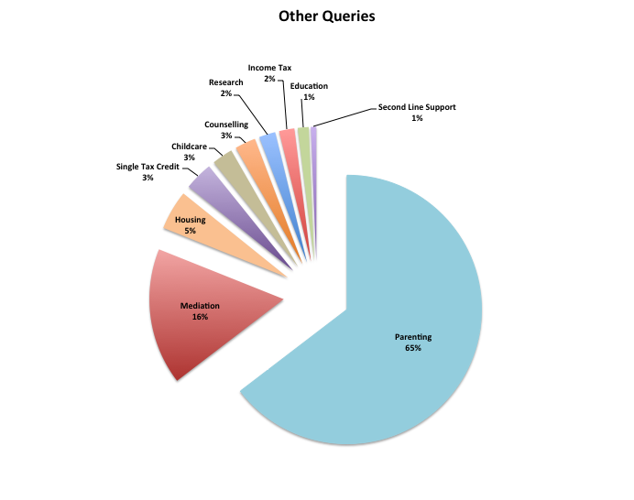
Chart 10

3. Miscellaneous

The majority of clients contacting Treoir found out about Treoir’s Specialist Information Centre online (42%), a 1% increase from 2014. The next two main groups contacting Treoir were Repeat Calls (20%) and clients who were referred by Citizens Information Centres (14%) with a 2% increase each from the previous year. There has also been a 1% increase in clients contacting Treoir because they are familiar with the services provided by the organisation (10%) (Chart 11).

"I think you are brilliant at your job.” (Caller, April 2015)

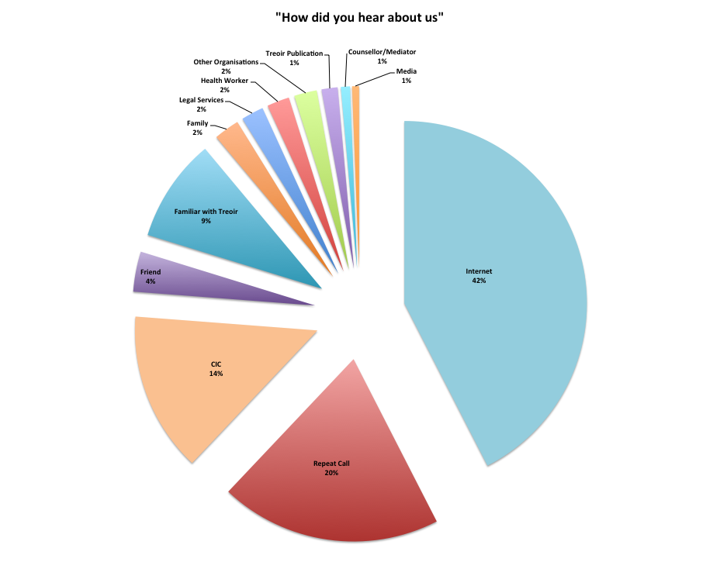
Chart 11

The majority of clients made contact with Treoir over the phone (87%), a 2% increase in comparison to 2014. In addition, there has been a 1% decrease in email queries (12%) and queries received via Facebook email and queries dealt with in person (1%) (Chart 12).

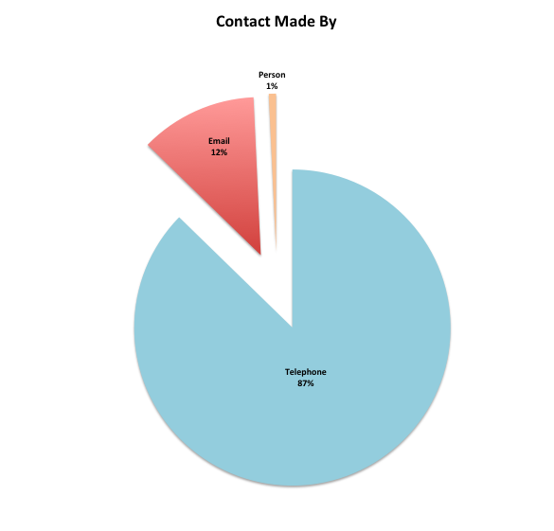
Chart 12

In terms of the age profile of those contacting Treoir, the client age group was 30-39 in 36% of the cases followed by 40+ in 35% of the cases and 25-29 in 18%. Clients age 20-24 amounted to 9% of the queries while clients under the age of 20 amounted to 2% (Chart 13).

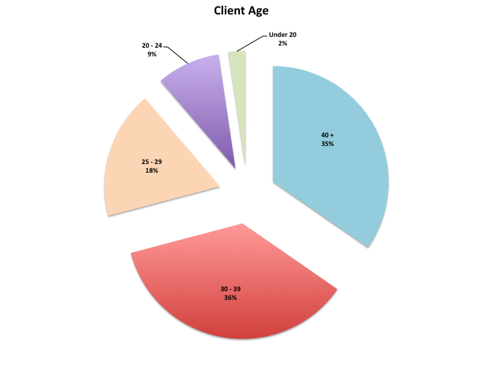

Chart 13

In 2015, 88% of callers were based in Ireland with the majority of calls received from clients living in Dublin followed by Cork, Galway, Kildare and Kerry. 6% of international calls came from EU Countries (6%) followed by non-European Union countries (4%) and UK (2%) (Chart 14).

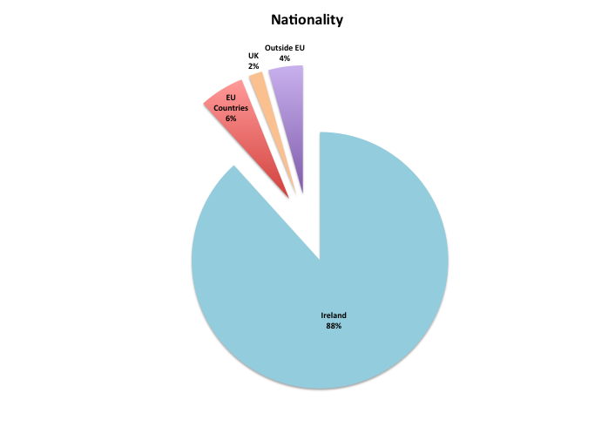
Chart 14

January and August were the months with the highest rate of queries while November and December were the months with the lowest number of queries (Chart 15).

"You are absolutely marvellous. I have talked to lots of other organisations and yes you are great! Thanks so much and…can I contact you again.” (Caller, September 2015)

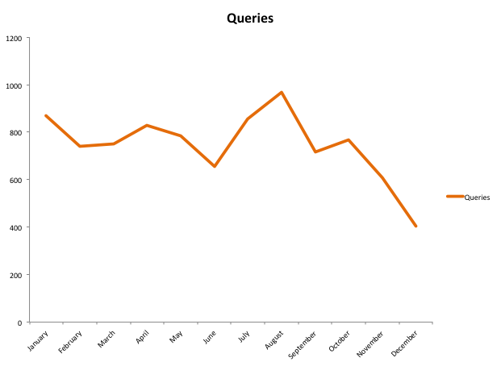

Chart 15

"I would like to thank you for your help to my son. He has spoken several times with your organisation and this has brought him some solace…It is heartening that organisations like yours exist to help people through the often heartbreaking situation that exists, especially for unmarried fathers.” (email from client, December 2015)

B. PUBLICATIONS

The Information Pack for Unmarried Parents was updated and printed (12,000 copies) in 2015, thanks to a grant from the HSE Sexual Health and Crisis Pregnancy Programme. This publication was widely distributed and multiple copies were automatically delivered to all CICs, CISs, Crisis Pregnancy Counselling Agencies and to all maternity hospitals. The availability of the 2015 Pack was advertised on Treoir’s e-bulletin, on Facebook, on the home page of Treoir’s website and was made available to download. The Pack was produced with a clear ‘warning’ sign on the front page announcing the imminent commencement of new family legislation and with a brief explanation on what this new legislation will mean for unmarried parents. An amendment sheet was produced and inserted in the Pack towards the end of 2015 outlining the changes in relation to social welfare as a result of Budget 2016.
All Treoir’s information leaflets were updated and printed during 2015. This includes information leaflets on access and custody, maintenance, guardianship, establishing paternity, passports, child abduction, step-parent adoption, unmarried fathers, cohabiting parents and shared parenting. Again, towards the end of 2015 many of these information leaflets were re-printed with a warning to alert users to the fact that much of the information contained would change on the commencement of new legislation.
The Treor-e-bulletin was produced on a quarterly basis during the year. This publication is made available to download from the Treoir website and is distributed by way of e-mail to approximately 600 recipients made up of Citizen Information Centres, HSE workers, TUSLA, crisis pregnancy counselling services, maternity hospitals, family resource centres, media and others.

"I am a Social Worker who was at the brilliant Treoir training with IASW. I got loads of really useful leaflets at the training” (email, October 2015)

C. WEBSITE

In 2015, there were 65,787 visitors to the Treoir website and 164,178 page views of whom 31% of visitors were return visitors. This is an increase of 8% on the figures for 2014. With regard to their location, 89% of viewers accessed the Treoir website from within Ireland, 4.5% from the UK and 1.5 from the U.S., followed by other countries to a lesser extent. The most visited area of the Treoir website was the fathers section, followed by the information sections on maintenance, guardianship, access and custody and birth registration in that order.

The Treoir website is updated regularly with changes in legislation, social welfare allowances and with other information relevant to unmarried parents. New and updated publications are made available to download. The ‘About ’ section is updated as necessary with changes to membership of the Council, Treoir Membership and every year with the Treoir Annual Report and Accounts.

During 2015 the Treoir website was updated in preparation for the commencement of new legislation. This was done by way of alerting users to the fact that newly introduced family legislation would, when commenced, affect the legal situation of many unmarried parents. Visitors were requested to check the Treoir home page for updates and/or to follow Treoir on Facebook for relevant commencement dates.

The Treoir home page, together with the LGBT News section, is regularly updated with news items relevant to unmarried parents.

"I was using your website last night and I was very pleased with the volume of information available. It was a big help…very user friendly.” (email from client, July 2015)

D. OUTREACH

Treoir provides outreach information workshops to groups of unmarried parents and to groups of workers who provide services to unmarried parents.
The aim of the workshops is to provide accurate and up to date information on matters of relevance to parents and their children. Topics covered include:
- the legal rights and responsibilities of parents who are not married to each other (such as guardianship, access, custody, birth registration, cohabitation, passports etc)
- social welfare allowances, employment and training/education opportunities which are available to parents
- shared parenting and explaining family relationships to children.
Workshops are tailored to respond to the needs of individual groups.

In 2015 Treoir provided 25 information workshops to groups throughout the country. Workshops took place in Cork, Donegal, Dublin, Galway, Kerry, Kildare, Limerick and Westmeath. Just under 500 people participated in the workshops, which were attended by parents and workers.

Eight workshops were delivered to parents in a variety of settings, including mothers participating in local training/education programmes, parents participating in a community based rehabilitation day programme for people in recovery from addiction, parents in residential units for homeless persons, fathers and mothers in Family Resource Centres.
Treoir was invited to participate in three workshops hosted by the Defence Forces as part of a Mens’s Health Awareness Day programme. The workshops were held in Custume Barracks in Athlone, Co. Westmeath; Finner Camp, Ballyshannon, Co. Donegal and the Air Corps at Baldonnel, Dublin. The workshops provided an opportunity to inform fathers of the legal rights and responsibilities of unmarried parents in respect of their children and to highlight the services that Treoir offers to unmarried parents.

Treoir provided 17 workshops to groups of workers who provide services to unmarried parents and their children. The workshops were attended by organisations providing accommodation and services to parents such as Focus Ireland, The Salvation Army, De Paul Society, Crosscare and Sophia Housing. Workshops were also attended by Hospital Social Workers, Crisis Pregnancy Counsellors, Workers from Community and Youth Services, Citizens Information Centres, Family Resource Centres, Tusla and the Irish Association of Social Workers.

The workshops briefed participants on the key changes to be introduced to family law when the Children And Family Relationshps Act 2015 and the Civil Registration (Amendment) Act 2014 are commenced.
"A huge thank you for your presentation to the Crisis Pregnancy Counselling Skills Group. The group truly appreciated your energy commitment and knowledge of this topic regarding lone parents.” (email from Anne McCarthy, Lead Tutor, CPC Skills, Maynooth University, December 2015)

"Many thanks for delivering the Treoir training yesterday. I received very good feedback from the Information Officer in Bray CIC. I had a quick look at the evaluation forms just now and all of the attendees have commended you on an excellent training session.” (email from Development Manager, CIS Bray)

POLICY DEVELOPMENT / RESEARCH

Treoir will advocate effectively on behalf of unmarried parents to ensure the best outcomes for them and their children

POLICY
Treoir aimed to deliver the above strategic priority through influencing family legislation, developing policy programmes informed by queries from Treoir’s National Specialist Information Service and working to promote the right of children to have a relationship with both parents where possible. As anticipated, 2015 was a busy year in terms of influencing the various pieces of legislation that were enacted.
Children and Family Relationships Act 2015

A very significant example of the effectiveness of Treoir’s advocacy work this year was the inclusion in the Children and Family Relationships Act 2015 of a provision that, at the time of registration of a birth, unmarried fathers be informed of their lack of rights and that registrars be empowered to witness the signing of the Statutory Declaration for Joint Guardianship. While this is a significant step forward it does not go far enough. This provision has not yet commenced.

Treoir has for many years promoted the setting up of a Central Register for Guardianship Agreements because of the hardship caused to unmarried fathers by not being able to prove guardianship. It is a huge disservice to this worthy piece of legislation that there will be no onus on the Registrar to keep a record of the fact that the father is a guardian. The Minister did commit to doing a scoping exercise on the feasibility of setting up a Central Register and Treoir will continue to press for this.

In addition, Treoir made a number of submissions and attended several meetings and hearings on issues with potential to affect unmarried parents and their children. These included:

- Submission to the Joint Committee on Health and Children on The Adoption (Information and Tracing) Bill. Treoir welcomed the Bill but also outlined its concerns including those in relation to information and tracing associated with adoptions that occurred in the past.

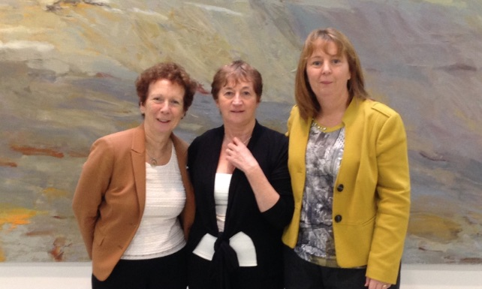

Picture shows Treoir’s Chair, Dr. Ruth Barrington, former CEO Margaret Dromey and Senator Jillian van Turnhout

- Pre-Budget 2016 Submission to the Department of Social Protection which concentrated on four areas which Treoir believes has potential to raise lone parent families out of poverty in a sustained way: housing, childcare, activation of lone parents on Jobseekers Transitional payment and Income Adequacy.
- Submission to the Courts Service relating to proposals for the new family and children court facilities in Dublin. Treoir recommended that accommodation be made available for services including Mediation Services, a legal information service and facilities for children.
- Submission to the Department of Justice and Equality in relation to the Children and Family Relationships Bill 2015.

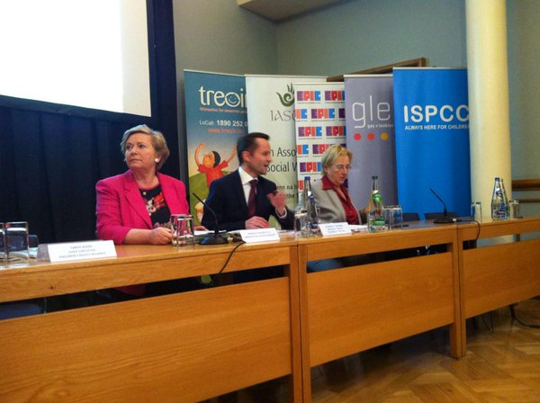

During 2015 Treoir actively supported the Children and Relationships Bill 2015 and significantly contributed to shape the Bill to promote the rights and best interests of unmarried parents and their children
TEEN PARENTS SUPPORT PROGRAMME

Treoir will support those working with young parents in Ireland

A. WHAT IS THE TPSP?

The TPSP consists of eleven separate projects located throughout the country in a range of statutory, community and voluntary organisations. The projects, which are funded by Tusla and the HSE, work with young people who become parents when they are aged 19 years or under and, where needed, support them until their children are 2 years of age. The main aims of the TPSP are to provide early interventions which enhance and support the wellbeing of young parents and their children, empower young parents in their parenting role and ensure equality of opportunity for parent and child. During 2015 the TPSP supported 940 young parents, their children and families.

B. TPSPS CO-ORDINATION AND SUPPORT

During 2015 the National Co-ordinator continued to support and co-ordinate the 11 TPSP projects throughout the country. This was achieved through:

- regular contact with projects and meetings with project staff and management when required

- keeping TPSP staff informed of changes in government policy and legislation in areas which affect young parents such as education, housing, social welfare, birth registration and guardianship

- maintaining contact with key staff in government departments and State agencies most relevant to young parents

- collecting, collating and analysing detailed data from the TPSP database in relation to referrals received and supports offered by the TPSP. This is used for the annual TPSP Summary of Work, to report to Tusla, to explore outcomes and to inform advocacy work undertaken by the National Co-ordinator on behalf of the TPSP and young parents nationally.

In addition to the TPSP database, in 2015, the National Co-ordinator provided the Corporate Planning and Corporate Performance Section (CPCP) of Tusla with quarterly updates on the numbers of young parents supported by the TPSP projects.

To ensure that communication flowed among all strands of the TPSP structure, in 2015 two separate meetings were organized for all TPSP staff, TPSP Host Organisations and the TPSP National Advisory Committee and followed up issues raised at these meetings such as Home Tuition, childcare and aspects of the supplementary welfare system.

In response to a request from TPSP staff, the National Co-ordinator also arranged training from Pavee Point in relation to engaging with the Roma community in Ireland.

The TPSP website (www.tpsp.ie) was updated regularly with items of interest to young parents and those involved with them. In 2015, there were over 64,000 viewings of the website. The Co-ordinator also acts as a source of information, advice and guidance for professionals working with young parents in areas where there is not a TPSP and directs them to other appropriate services.

During 2015 the TPSP organized two workshops targeting those working with young fathers. These built on the “Focus on Fathers” materials developed previously by the Louth TPSP and funded at that time by the Crisis Pregnancy Agency. These workshops were co-facilitated by Treoir’s Information and Training Officer and Finian Murray, Men’s Health Development Worker, HSE Dublin North East. The Focus on Fathers Workshops are ways in which young parents living in areas where there is not a TPSP can nonetheless benefit to some extent from the resources and expertise of the TPSP. They are also a way of raising awareness among professionals of the issues faced by young fathers in relation to having guardianship of and/or access to their children.

One of the other main ways in which the TPSP aims to support all young parents in Ireland is through advocating on their behalf. During 2015 this was achieved mainly through meetings with key policy makers that focused particularly on the needs of young parents. These include the Higher Education Authority; Tusla Education Welfare Services; the Department of Children & Youth Affairs (DCYA); Co-ordinators of Children and Young People Services Committees (CYPSC); managers of Prevention, Partnership and Family Support (PPFS) in Tusla and housing charities such as Threshold and Focus Ireland. The TPSP National Co-ordinator also represents the needs of teen parents and unmarried parents on The Parenting Network facilitated by the Centre for Effective Services.

This type of advocacy work aims to keep the needs of teen parents to the fore among relevant policy makers and ensures that the TPSP is included in national consultations such as Tusla’s consultation in 2015 with the Community and Voluntary Sector working in Family Support and the Needs Analysis of the Roma Community in Ireland carried out by Pavee Point in 2015.

"Thank you for yesterday most informative day. I had a young dad in this morning and I informed him about guardianship and what to do his reaction was over the moon because he was completely misinformed….(email from worker at TPSP workshop, January 2015)

RAISING AWARENESS / PUBLIC RELATIONS

Treoir will continue to raise awareness of issues affecting unmarried parents and will promote the availability of Treoir Services

A. Media

- Press Releases
Most of the press releases in 2015 related to the significant family legislation that was enacted in 2015. These included:
Compulsory registration of father’s name on child’s birth certificate: Treoir welcomed the enactment of the Civil Registration (Amendment) Act 2014 in December 2014. Once commenced, certain provisions of this Act will place a duty on unmarried parents to register the father’s name on the birth certificate of their child. Children need to know as much as possible about both their parents in order to have a good sense of their own identity and personal history. Having the father’s name on his child’s birth cert is an important step in achieving this.
Nothing for non-cohabiting fathers in Children and Family Relationships Bill: Treoir called for some specific amendments to ensure that inequalities relating to unmarried fathers and their children are finally tackled. Treoir recommended that at a minimum the legislation makes it mandatory to provide unmarried parents with information at the point of birth registration on their legal position in relation to their children and on the options open to them. Opposition politicians repeatedly raised many of the issues that were highlighted by Treoir during the discussion of the Bill in the Oireachtas. As a consequence of Treoir’s efforts, the Minister for Justice committed to
    - holding a public information campaign and to
    - doing a scoping exercise/report on the feasibility of setting up a Central Register for Guardianship and
    - reviewing the legislation.
- Media Interviews
Treoir was interviewed by numerous radio stations, both local and national, on various topics mainly relating to forthcoming family legislation and its implications for unmarried parents. Staff of Treoir appeared on RTE television, UTV Ireland and TV3 and the chairwoman appeared on RTE’s The Week in Politics and Six One News to debate and discuss the issues. Treoir was consulted by researchers of the TV Soap ‘Red Rock’ in relation to its storyline about an unmarried couple. Several articles and letters from Treoir were published in the national media in print and online during the year and Treoir was widely quoted in several publications in relation to significant items of legislation.
- It Says in the Papers
Treoir continued to provide its daily news service for members of Treoir, providing links to items from the three national newspapers that are relevant to unmarried parents and those working with them.

B. E-Bulletin
Treoir’s online quarterly news bulletin kept our members up-to-date on items of interest including recent legislation, changes in social welfare, upcoming conferences/workshops, new publications etc.
C. Social Media
Many of the posts on our Facebook page generated a great deal of discussion and debate among our followers. Shared parenting issues, father’s name on the child’s birth certificate, the Children and Family Relationships Bill were some of the topics that were teased out, discussed and often hotly debated.
D. Google Adwords Grant
Google continued its generous grant to Treoir ensuring that users searching in Google for information relevant to unmarried families would be directed to the Treoir’s website. Significantly 42% of clients contacting Treoir found out about Treoir’s Specialist Information Centre through Google Internet search.
E. Promoting Treoir Services
Treoir’s national confidential information service, and website, was available to all who were in need of up-to-date and accurate information relating to legal, social welfare, shared parenting etc. and other issues concerning unmarried parents and their children. In 2015, researchers from the TV drama “Red Rock” had regular contact with Treoir looking for specialised information regarding the particular circumstances of unmarried parents in order to develop a story line. To date this TV drama has attracted 2.3 million viewers and Treoir and HSE Sexual Health and Crisis Pregnancy Programme contact details are displayed on TV3’s website helpline.
F. Database
Treoir’s database was strategically updated in 2015 to include key media and political contacts in order to support the Children and Family Relationship Bill advocacy campaign. The issues highlighted by Treoir in media press releases and submissions attracted significant media and political attention with considerable results. Points highlighted by Treoir were repeatedly raised by politicians in the opposition making Treoir the main organisation consistently being referred to. As a result, Minister Fitzgerald committed to holding a public information campaign on guardianship, to undertaking a scoping exercise on the feasibility of setting up a Central Register and to reviewing the legislation in two years time.
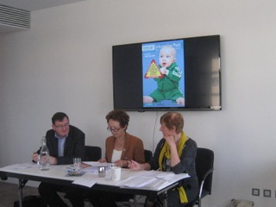
Left: Treoir’s Chair, Dr. Ruth Barrington, and Treasurer, Thomas Quigley with CEO Margaret Dromey at Treoir’s Annual General Meeting 2014.

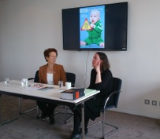
Right: Treoir’s Chair, Dr. Ruth Barrington with Dara Breathnach, Department of Justice and Equality, who presented a summary of the key provisions in the Children and Family Relationships Act 2015

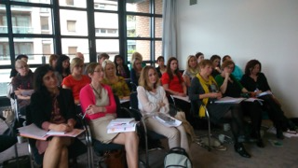


Left: Staff and Members at the Annual General meeting 2014.

Right: Treoir’s Council Members - Ciara McKenna, (National Maternity Hospital);
Mary McCarthy (Life Pregnancy Care); Marie Naughton (Here-2-Help)

GOVERNANCE

Treoir will have a robust governance and HR system to deliver a professional service which is fully compliant with company and charity legislation

The Board members, under the chairmanship of Dr. Ruth Barrington, closely monitored the governance of the organisation during 2015. The Board met six times during the year and the Audit and Finance Committee met five times. Browne Murphy and Hughes auditors were engaged to prepare the audited accounts and to file accounts with the Companies Registration Office.

Treoir is keenly aware of its responsibilities in relation to the use of public funds it receives and endeavours to maintain the highest possible level of service quality. Every effort was made to adhere to the good governance requirements of funders. Staff salaries were originally in line with HSE grades but no increments have been paid since 2009 and salaries were reduced by 10% in 2010. A defined contribution staff pension scheme is in operation. There is not a defined benefit scheme.

The past number of years have been particularly challenging for Treoir due to a significant reduction in funding and staff. Despite this there has been no reduction in the delivery and quality of Treoir’s activities and staff have met the increasing demand for the service.

Acknowledgements

We wish to thank the HSE, HSE Sexual Health and Crisis Pregnancy Programme, TUSLA and the Citizens Information Board without whose financial support the organisation would not exist.

In addition, we would like to thank Google for their annual AdWords in-kind advertising grant to promote Treoir’s Specialist Information Service on Google search result pages.

We thank Dr. Geoffrey Shannon and Dr. Fergus Ryan for their willingness to help clarify complex legal issues for Treoir for no financial gain.

Staff of various government departments have kindly given of their time to Treoir either through making presentations or discussing policy issues. In particular, we would like to thank Dara Breathnach for an excellent presentation at our AGM 2015.

Rosemary Grant continues to chair the National Advisory Committee of the Teen Parents Support Programme with great enthusiasm. We thank her sincerely for that.

Treoir, 14 Gandon House, IFSC, Dublin 1 – Tel: 01 6700 120 – www.treoir.ie - info@treoir.ie - facebook.com/treoir

