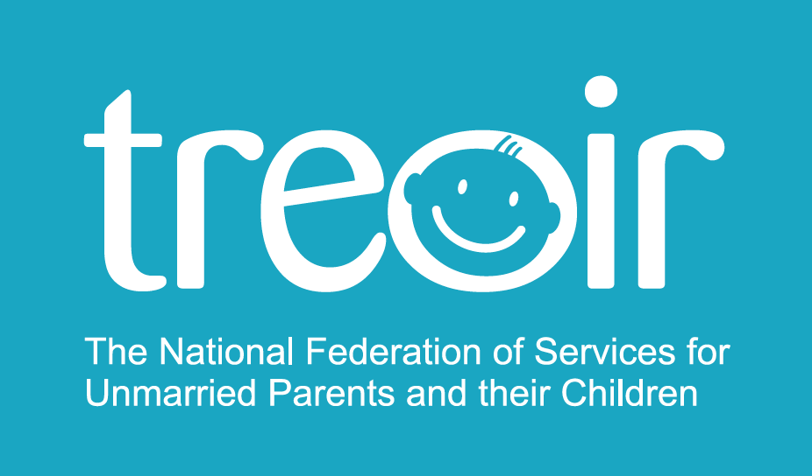

Treoir Press Release (Friday 6th May 2016)

Publication of the Adoption (Amendment)
Bill 2016

Treoir welcomes the publication of the Adoption (Amendment) Bill 2016 which amends the Adoption Act 2010 to give legislative effect to the thirty-first amendment of the Constitution (Children) Act 2012. The Bill attempts to amend adoption law to recognise those who are caring for children, irrespective of their biological ties.
In particular Treoir welcomes that the best interests of the child will be the paramount consideration in relation to any adoption matter, application or proceedings. The Bill also makes it compulsory that the views of the child should be ascertained and be given due weight by the Adoption Authority or by the court.
Greg Straton, Treoir’s Chief Executive Officer, said: “Treoir welcomes the many positive changes proposed in the bill, in particular, the provision allowing step-parent adoption without the peculiar requirement for the biological parent to adopt his or her own child. We look forward to discussing the rights and responsibilities of unmarried parents with the relevant policy makers’.

For further information contact:

Treoir

Greg Stration, CEO
Mobile: 087 971 48 90
Phone: 01 6700 120
Email: greg@treoir.ie

Notes to the Editor

About Treoir

Treoir is celebrating its 40th.

Treoir is the Irish word for direction and guidance. Treoir is a membership organisation which promotes the rights of unmarried parents (both opposite and same sex) and their children in Ireland. Treoir operates a National Specialist Information Service for unmarried expectant parents, unmarried parents, their families and those involved with them and advocates on their behalf.

LoCall: 1890 252 084
Email: info@treoir.ie
Website: www.treoir.ie
Follow us on Facebook and Twitter

Treoir believes that unmarried families should have the same right to respect, support, protection and recognition as families based on marriage.

Treoir, the national federation of services for unmarried parents and their children, is a company limited by guarantee not having a share capital, registered in Dublin, Ireland, registered company number 82321.

Treoir is also a charity with CHY number 8877

Directors: R Barrington, Chair, B Collins, A Dowling-Deignan, A Egan, L Graham, C. Hughes, M McCarthy, C McKenna, M Naughton, D Ní Riordáin, T Quigley, S Roddy.

