Teen Parents Support Programme
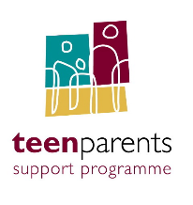
Focus on Fathers
Free one-day Workshop
Thursday 12th March 2020
9.30am to 4.30pm
Aisling Hotel, Parkgate Street, Dublin 8
www.ashlinghotel.ie
Registration of Interest Form
Places are limited for this Workshop and completion of this Registration of Interest Form does not guarantee you a place.

1. Name

2. Name of employer

3. Role in organisation

4. Address

5. Contact Number

6. Email Address

Return by Friday 21st February 2020 to Margaret Morris, National Co-ordinator TPSP, Treoir, 28 North Great Georges Street, Dublin 1
Or contact Margaret directly at tpsp@treoir.ie 087 2518428

